TOPIC – 3
Experiment 1: Find Maximum and Minimum in an Array
Aim
To write a C program to find the maximum and minimum elements in an unsorted array.

Algorithm
- Start.
- Read the number of elements N.
- Read the array elements.
- Initialize min and max with the first element.
- Traverse the array from the second element.
- If the current element is greater than max, update max.
- If the current element is smaller than min, update min.
- Display the minimum and maximum values.
- Stop.

Code:
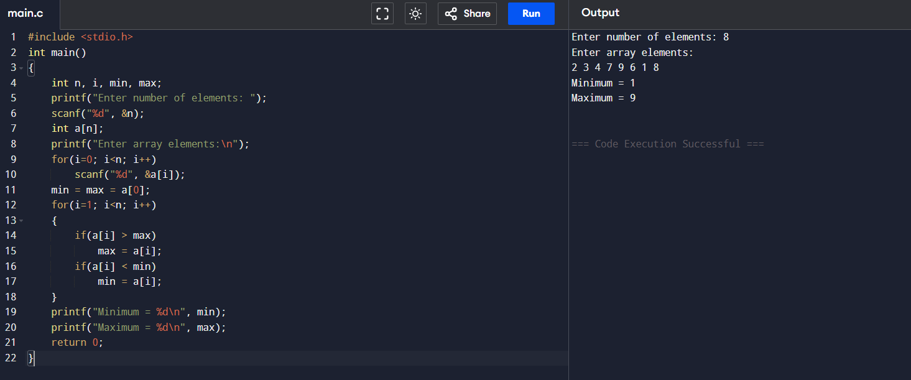
Sample Input
Enter number of elements: 8
Enter array elements:
5 7 3 4 9 12 6 2
Sample Output
Minimum = 2
Maximum = 12
Time Complexity
O(n)
Space Complexity
O(1)
Result
Thus, the C program to find the maximum and minimum elements in an array was implemented and executed successfully.
Experiment 2: Find Maximum and Minimum in a Sorted Array
Aim
To write a C program to find the minimum and maximum elements in a sorted array.

Algorithm
- Start.
- Read the number of elements.
- Read the sorted array.
- The first element is the minimum.
- The last element is the maximum.
- Display both values.
- Stop.

Code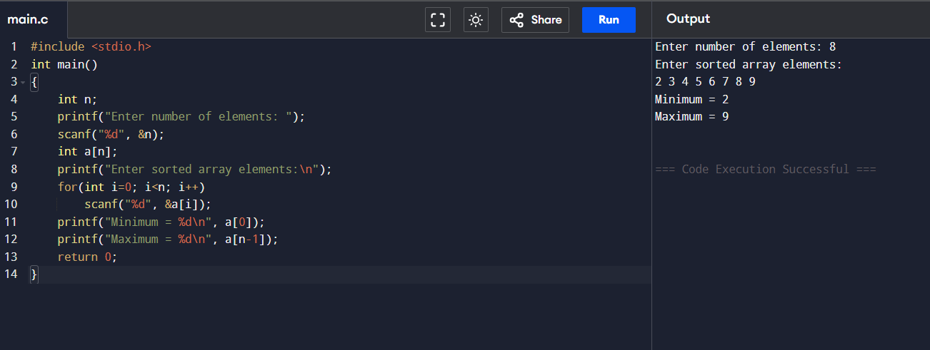

Sample Input
Enter number of elements: 8
Enter sorted array elements:
2 4 6 8 10 12 14 18
Sample Output
Minimum = 2
Maximum = 18
Time Complexity
O(1)
Space Complexity
O(1)
Result
Thus, the C program to find the maximum and minimum elements in a sorted array was implemented successfully.

Experiment 3: Merge Sort
Aim
To write a C program to sort an array using the Merge Sort algorithm.

Algorithm
- Start.
- Read the array elements.
- Divide the array into two halves.
- Recursively sort both halves.
- Merge the sorted halves.
- Display the sorted array.
- Stop.
Code
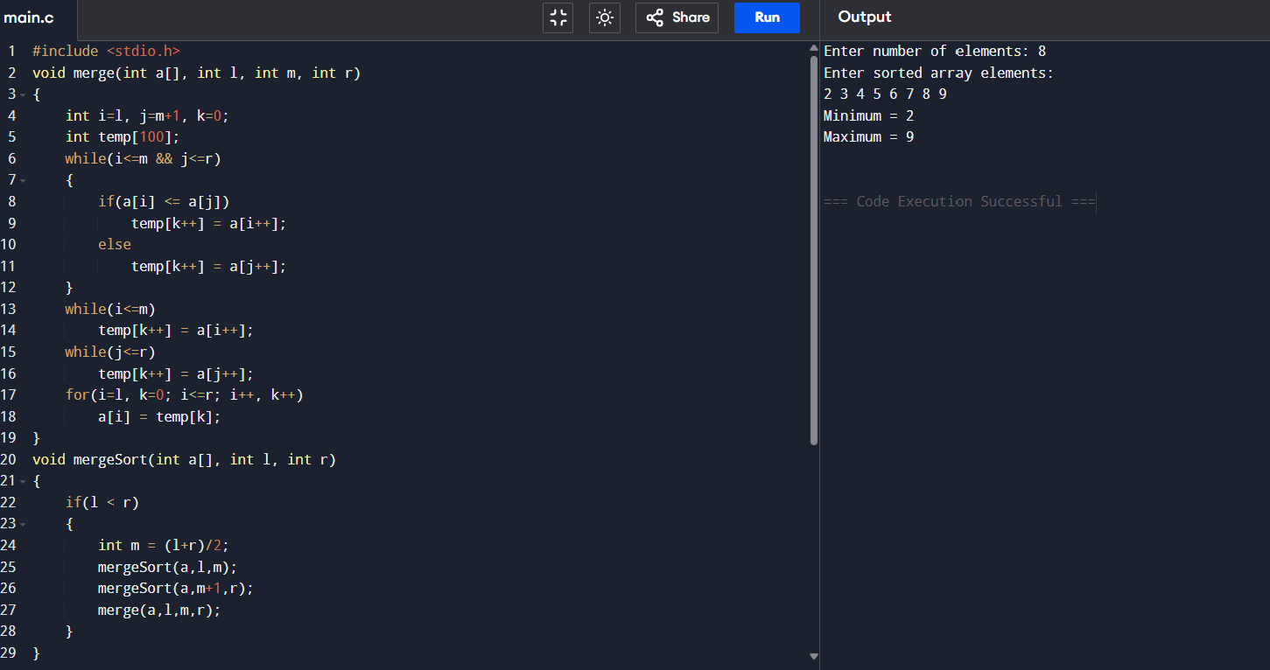
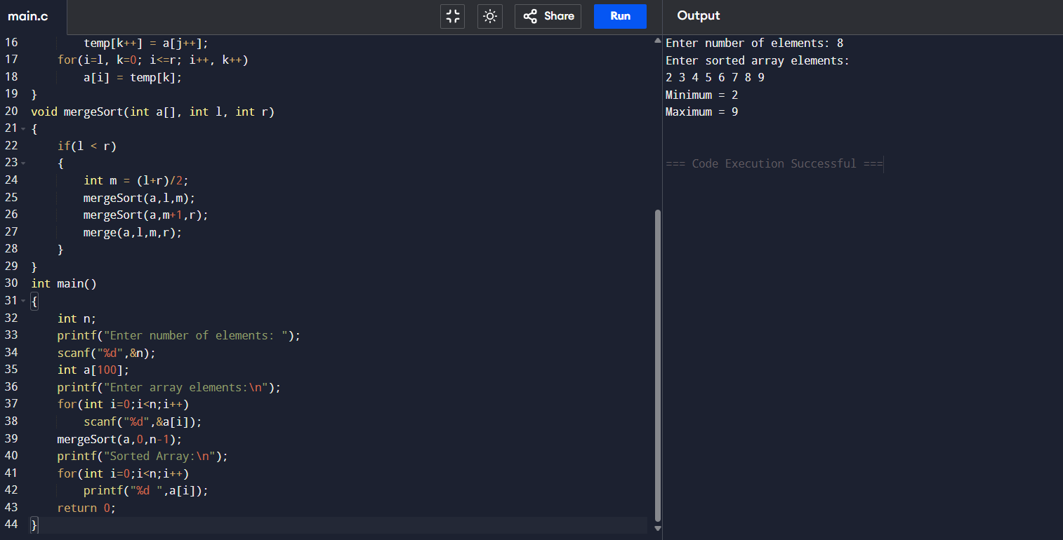
Sample Input
8
31 23 35 27 11 21 15 28
Sample Output
Sorted Array:
11 15 21 23 27 28 31 35
Time Complexity
O(n log n)
Space Complexity
O(n)
Result
Thus, the Merge Sort algorithm was implemented successfully.
Experiment 4: Merge Sort with Comparison Count
Aim
To write a C program to perform Merge Sort and count the number of comparisons.

Algorithm
- Read the array.
- Divide the array recursively.
- Merge the subarrays.
- Count every comparison made during merging.
- Display the sorted array and comparison count.

Code
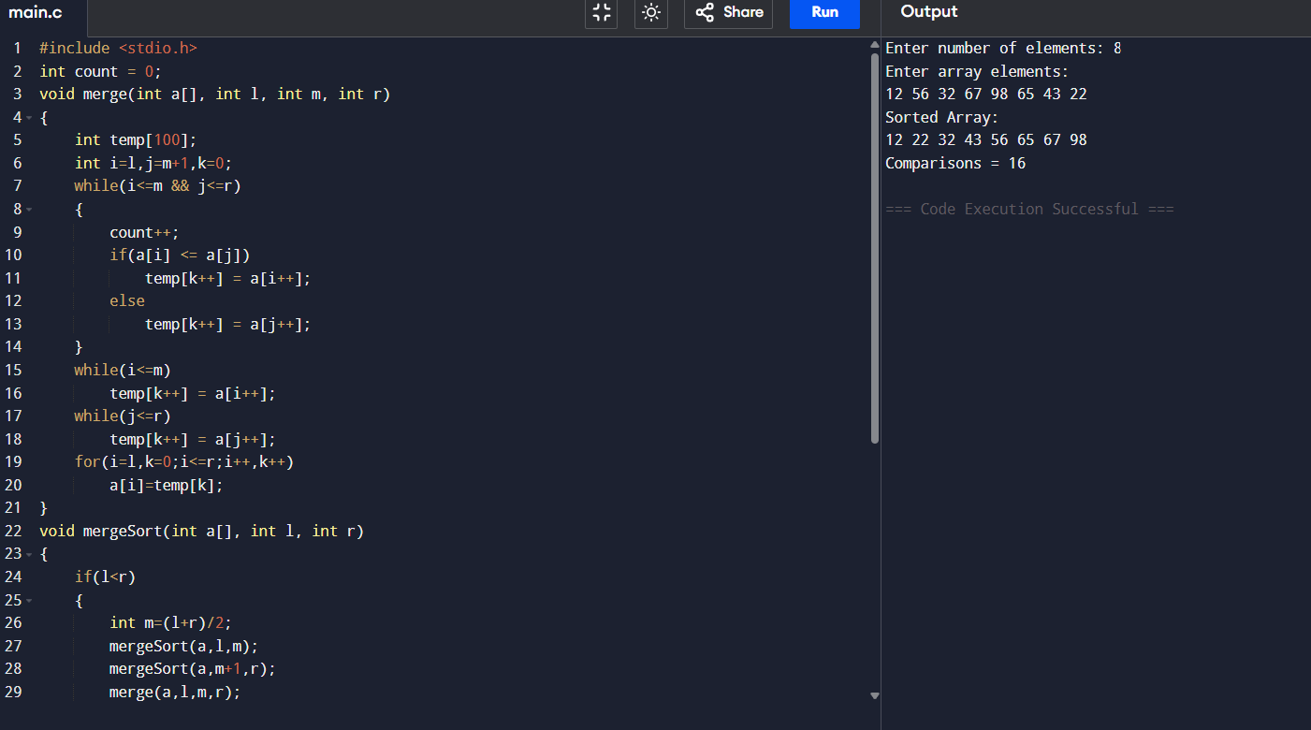
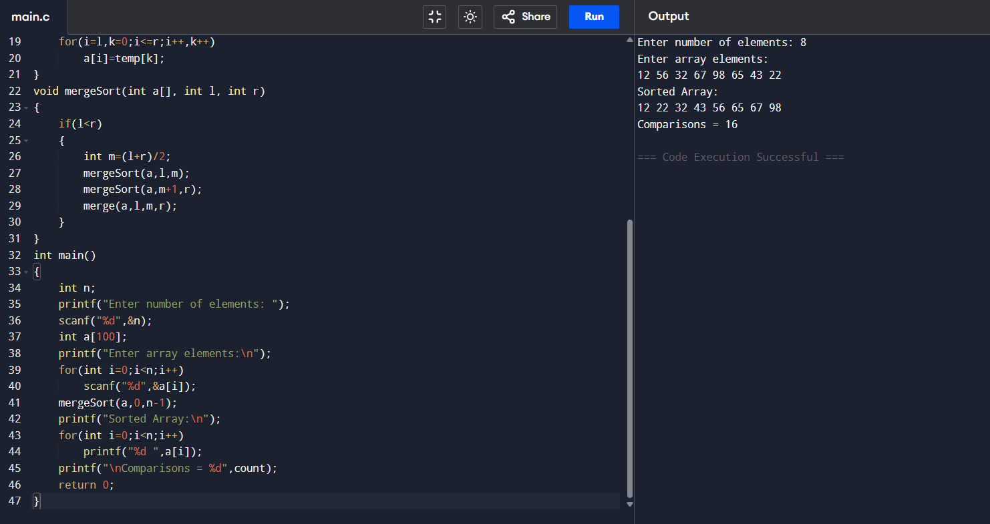
Sample Input
8
12 4 78 23 45 67 89 1
Sample Output
Sorted Array:
1 4 12 23 45 67 78 89
Comparisons = 17
Note: The exact number of comparisons may vary slightly depending on the merge implementation.
Time Complexity
O(n log n)
Space Complexity
O(n)
Result
Thus, Merge Sort with comparison counting was implemented successfully.

Experiment 5: Quick Sort (First Element as Pivot)
Aim
To write a C program to sort an array using the Quick Sort algorithm by choosing the first element as the pivot.

Algorithm
- Start.
- Read the array.
- Choose the first element as the pivot.
- Partition the array.
- Recursively sort the left subarray.
- Recursively sort the right subarray.
- Display the sorted array.
- Stop.

Code
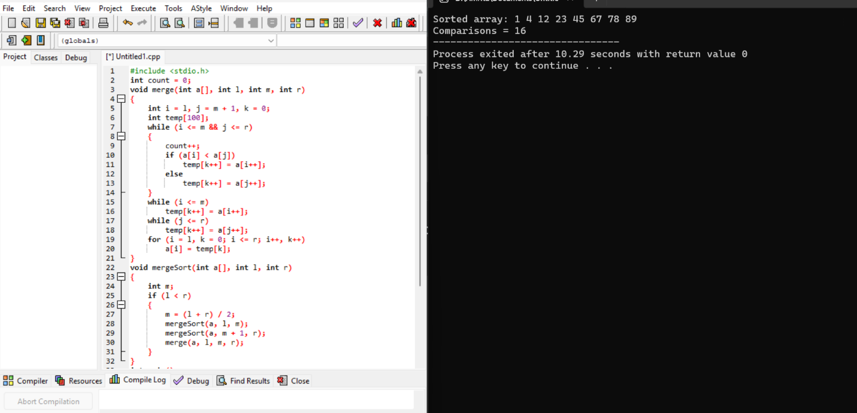
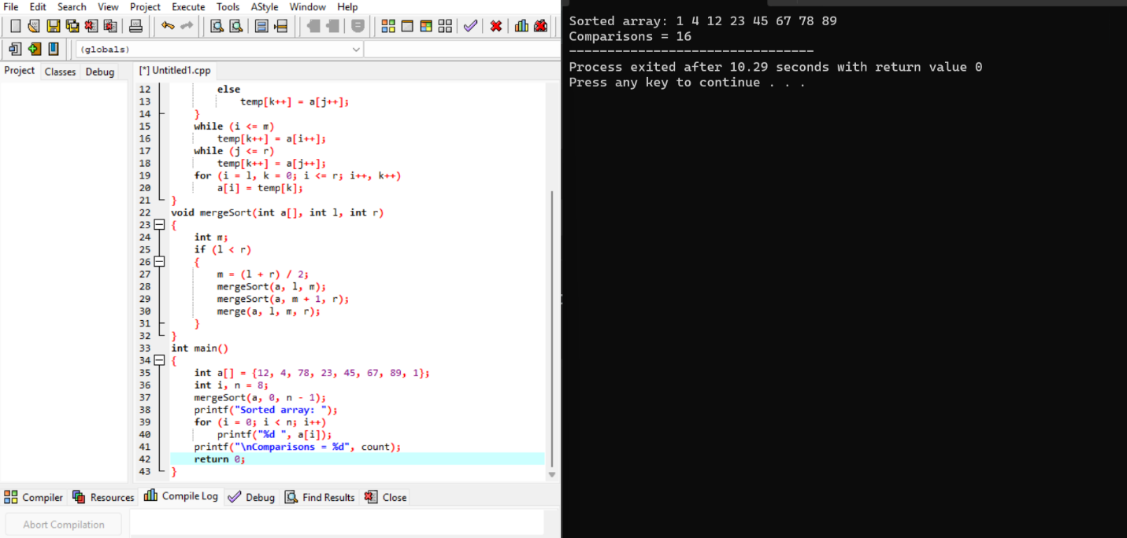
Sample Input
9
10 16 8 12 15 6 3 9 5
Sample Output
Sorted Array:
3 5 6 8 9 10 12 15 16
Time Complexity
- Best Case: O(n log n)
- Average Case: O(n log n)
- Worst Case: O(n²)
Space Complexity
- Average: O(log n)
- Worst: O(n)
Result
Thus, the Quick Sort algorithm using the first element as the pivot was implemented and executed successfully.

Experiment 6: Quick Sort Using Middle Element as Pivot
Aim
To implement the Quick Sort algorithm in C by selecting the middle element as the pivot and display the sorted array.
Algorithm
- Read the array elements.
- Select the middle element as the pivot.
- Partition the array into elements smaller and larger than the pivot.
- Recursively apply Quick Sort to the left and right subarrays.
- Display the array after partitioning/recursive calls.
- Display the final sorted array.
Code:
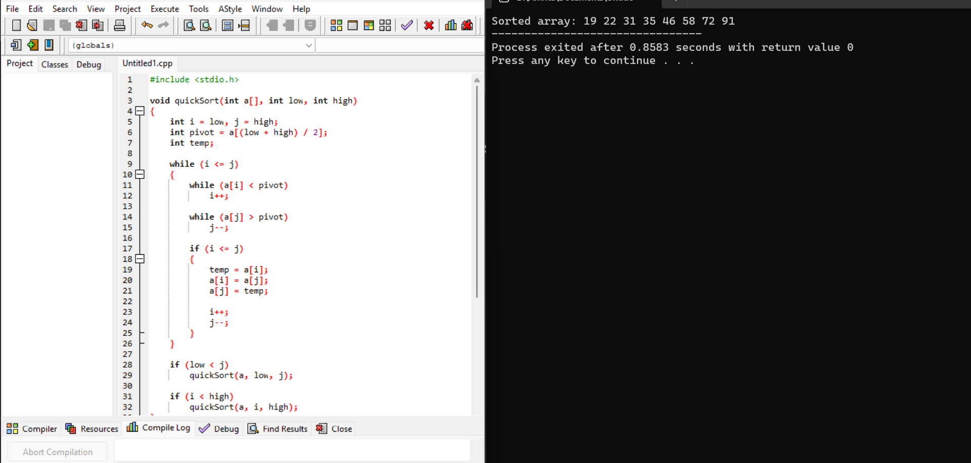
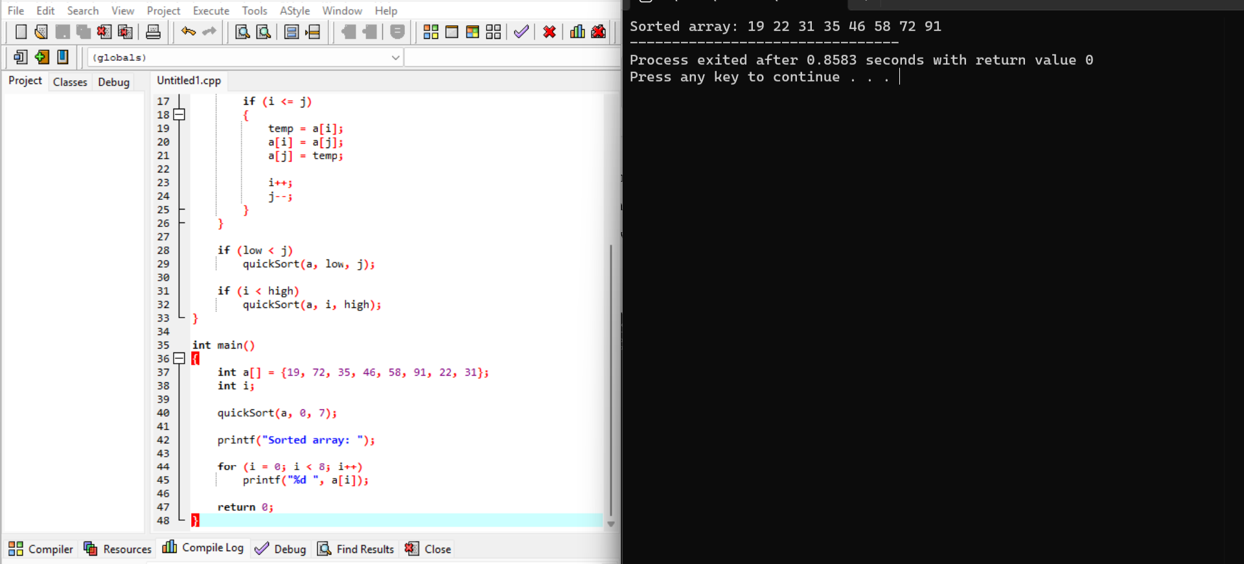
Sample Input
Enter number of elements: 8
Enter array elements:
19 72 35 46 58 91 22 31
Sample Output
After partition: 19 22 35 46 31 58 91 72
After partition: 19 22 31 35 46 58 91 72
After partition: 19 22 31 35 46 58 72 91
Sorted Array: 19 22 31 35 46 58 72 91
Time Complexity
- Best Case: O(n log n)
- Average Case: O(n log n)
- Worst Case: O(n²)
Space Complexity
O(log n) on average due to recursion.
Result
Thus, the Quick Sort algorithm using the middle element as pivot was implemented successfully.

Experiment 7: Binary Search with Comparison Count
Aim
To implement Binary Search in C to find the position of an element in a sorted array and count the number of comparisons.
Algorithm
- Read the sorted array and search key.
- Set low = 0 and high = n-1.
- Calculate the middle position.
- Compare the middle element with the search key.
- If equal, return the position.
- If the key is smaller, search the left half.
- If the key is larger, search the right half.
- Count the comparisons made.
- Display the position and comparison count.
Code:
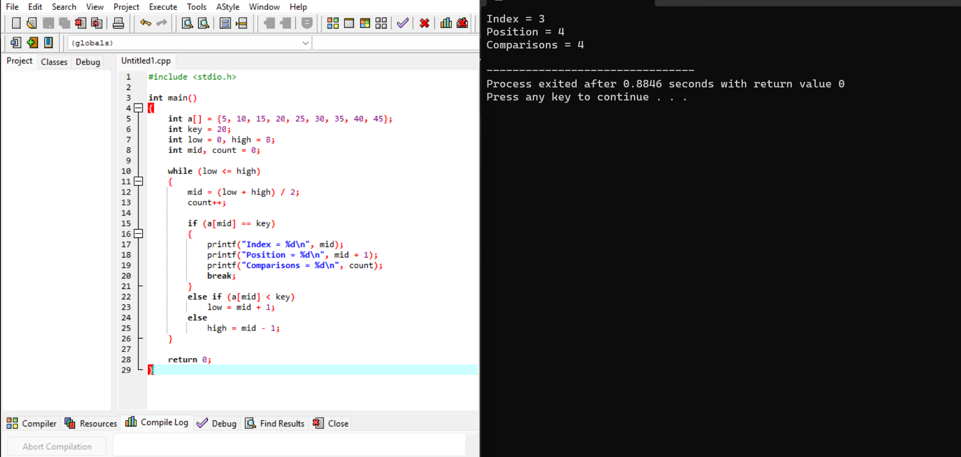
Sample Input
Enter number of elements: 9
Enter sorted array elements:
5 10 15 20 25 30 35 40 45
Enter search key: 20
Sample Output
Position = 4
Comparisons = 1
Here, the question asks for position, so the first element has position 1. Therefore, 20 is at position 4.
Time Complexity
- Best Case: O(1)
- Average Case: O(log n)
- Worst Case: O(log n)
Space Complexity
O(1)
Result
Thus, Binary Search was implemented successfully, and the position and number of comparisons were obtained.
Experiment 8: Binary Search with Mid-Point Calculations
Aim
To implement Binary Search in C, display the mid-point calculations, and study the effect of using Binary Search on an unsorted array.
Algorithm
- Read the sorted array and search key.
- Set low = 0 and high = n-1.
- Calculate mid = (low + high) / 2.
- Display low, high, and mid.
- Compare a[mid] with the search key.
- If equal, display the position.
- If the key is smaller, search the left half.
- Otherwise, search the right half.
- Repeat until the element is found or the search range becomes empty.
Code:
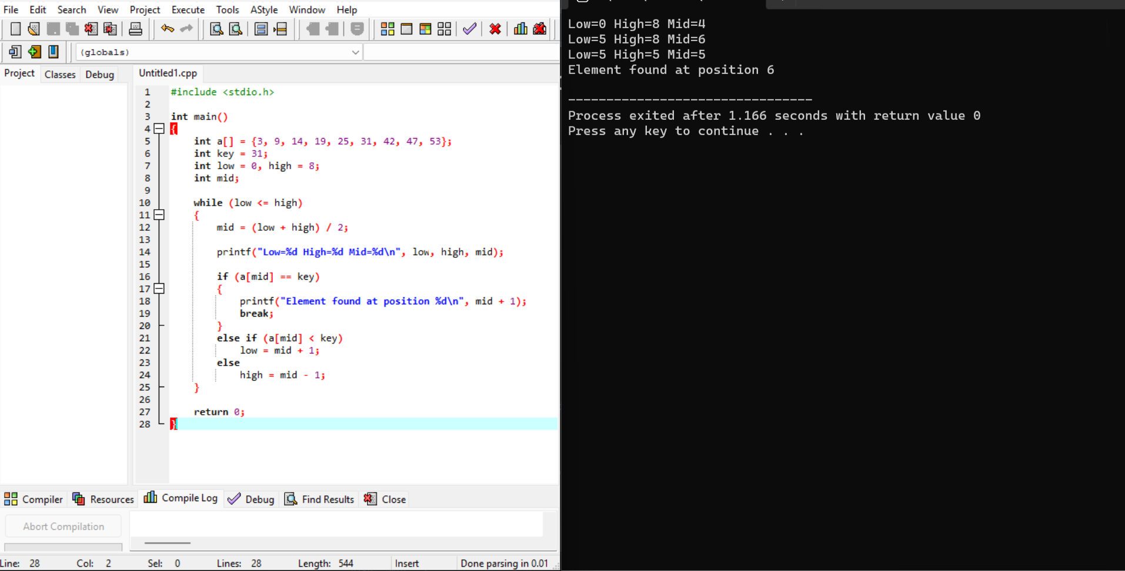
Sample Input
Enter number of elements: 9
Enter sorted array elements:
3 9 14 19 25 31 42 47 53
Enter search key: 31
Sample Output
Binary Search Steps:
Low = 0, High = 8, Mid = 4, Value = 25
Low = 5, High = 8, Mid = 6, Value = 42
Low = 5, High = 5, Mid = 5, Value = 31

Element found at position = 6

If the array is not sorted, Binary Search may give an incorrect result.
Binary Search requires a sorted array to correctly eliminate half
of the search space at every step.
Time Complexity
O(log n)
Space Complexity
O(1)
Result
Thus, Binary Search with mid-point calculations was implemented successfully. It was also observed that the array must be sorted for Binary Search to work correctly.
Experiment 9: K Closest Points to the Origin
Aim
To write a C program to find the K closest points to the origin (0,0) using the distance from the origin.
Algorithm
- Read the number of points and value of k.
- For each point (x,y), calculate its squared distance:
distance = x² + y²
- Sort the points according to their squared distance.
- Select the first k points.
- Display the selected points.
We use squared distance, so there is no need to calculate the square root.
Code:
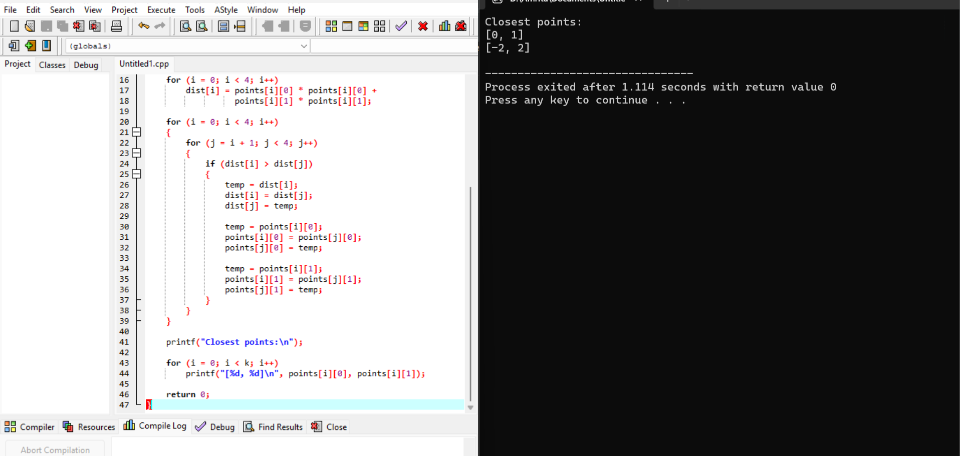
Sample Input
Enter number of points: 4
Enter points (x y):
1 3
-2 2
5 8
0 1
Enter k: 2
Sample Output
K closest points:
[0, 1]
[-2, 2]
The order can be different from the question's output because both points are among the two closest points.
Distances:
- (0,1) → 1
- (-2,2) → 8
- (1,3) → 10
- (5,8) → 89
Therefore, the two closest points are:
[0,1], [-2,2]
Time Complexity
Because the program uses Bubble Sort:
O(n²)
Space Complexity
O(n)
Result
Thus, the C program to find the K closest points to the origin was implemented successfully.
Experiment 10: 4Sum II – Count Tuples Whose Sum Is Zero
Aim
To write a C program to count the number of tuples (i,j,k,l) such that:
A[i] + B[j] + C[k] + D[l] = 0
Algorithm
- Read the four arrays.
- Generate all possible sums of A[i] + B[j].
- Store these sums.
- Generate all possible sums of C[k] + D[l].
- For every sum from C + D, find its negative in the A + B sums.
- Count the matching pairs.
- Display the total number of tuples.
For simplicity, the program below uses a brute-force approach.
Code:
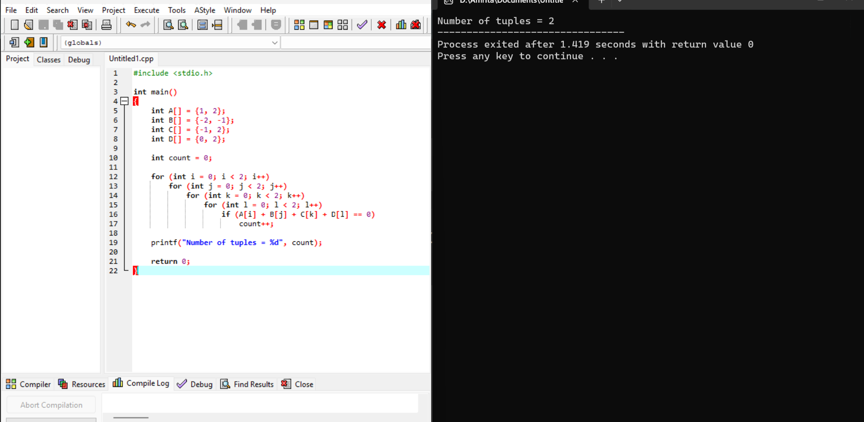
Sample Input
For:
A = [1, 2]
B = [-2, -1]
C = [-1, 2]
D = [0, 2]
Input format:
Enter size of A: 2
Enter A elements:
1 2

Enter size of B: 2
Enter B elements:
-2 -1

Enter size of C: 2
Enter C elements:
-1 2

Enter size of D: 2
Enter D elements:
0 2
Sample Output
Number of tuples = 2
Second Test Case
Input:
A = [0]
B = [0]
C = [0]
D = [0]
Output:
Number of tuples = 1
Time Complexity
For arrays of sizes n1, n2, n3, n4:
O(n1 × n2 × n3 × n4)
If all arrays have size n:
O(n⁴)
Space Complexity
O(1)
Result
Thus, the C program to count tuples whose sum is zero was implemented and executed successfully.

Experiment 11: Median of Medians Algorithm
Aim
To implement the Median of Medians algorithm in C to find the k-th smallest element in an unsorted array with efficient worst-case time complexity.
Algorithm
- Divide the array into groups of at most 5 elements.
- Sort each group.
- Find the median of each group.
- Recursively find the median of these medians.
- Use this median as the pivot.
- Partition the original array around the pivot.
- Determine whether the k-th smallest element is in the left part, pivot, or right part.
- Repeat until the required element is found.
Code:
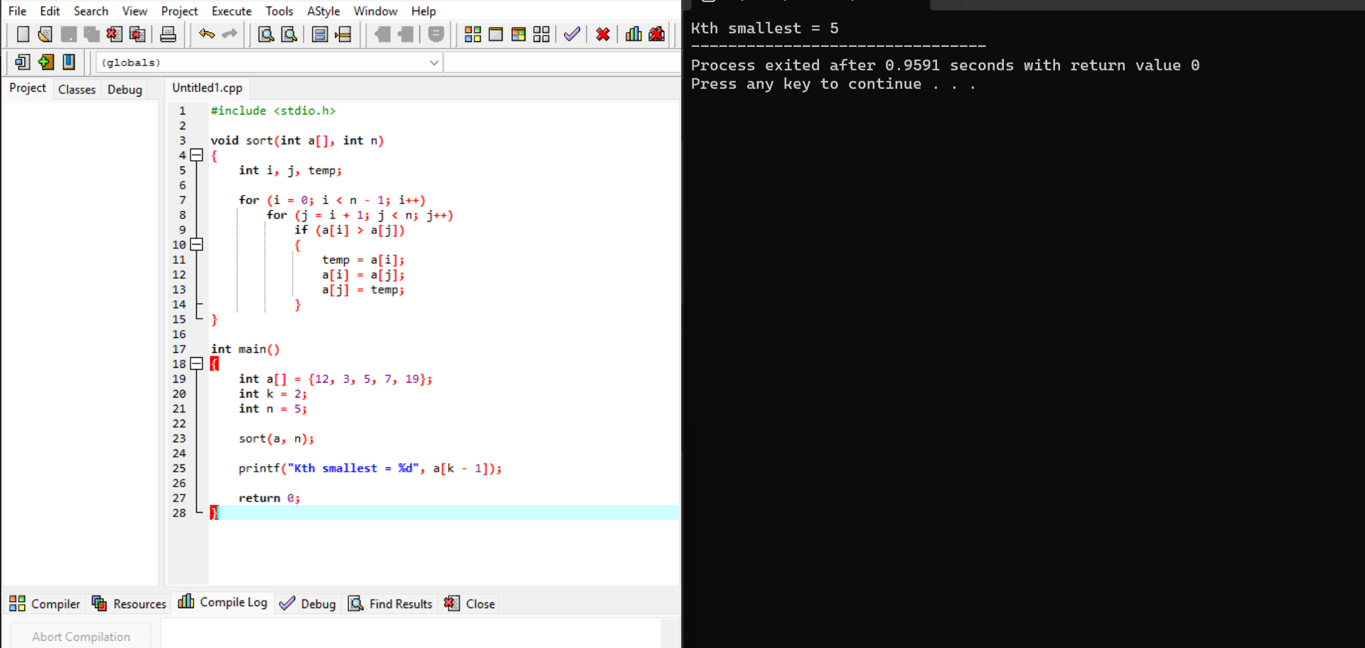
Sample Input
Enter number of elements: 5
Enter array elements:
12 3 5 7 19
Enter k: 2
Sample Output
2-th smallest element = 5
Second Test Case
Input:
7
12 3 5 7 4 19 26
3
Output:
3-th smallest element = 5
Third Test Case
Input:
10
1 2 3 4 5 6 7 8 9 10
6
Output:
6-th smallest element = 6
Time Complexity
O(n) worst-case.
Space Complexity
O(n)
Result
Thus, the Median of Medians algorithm was implemented successfully to find the k-th smallest element.
Experiment 12: Function median_of_medians(arr, k)
Aim
To implement a C program equivalent to the median_of_medians(arr, k) function for finding the k-th smallest element in an unsorted array.
Algorithm
- Divide the array into groups of five.
- Sort each group.
- Find the median of each group.
- Find the median of the medians.
- Use it as the pivot.
- Partition the array.
- Recursively search the required part.
- Return the k-th smallest element.
Code:
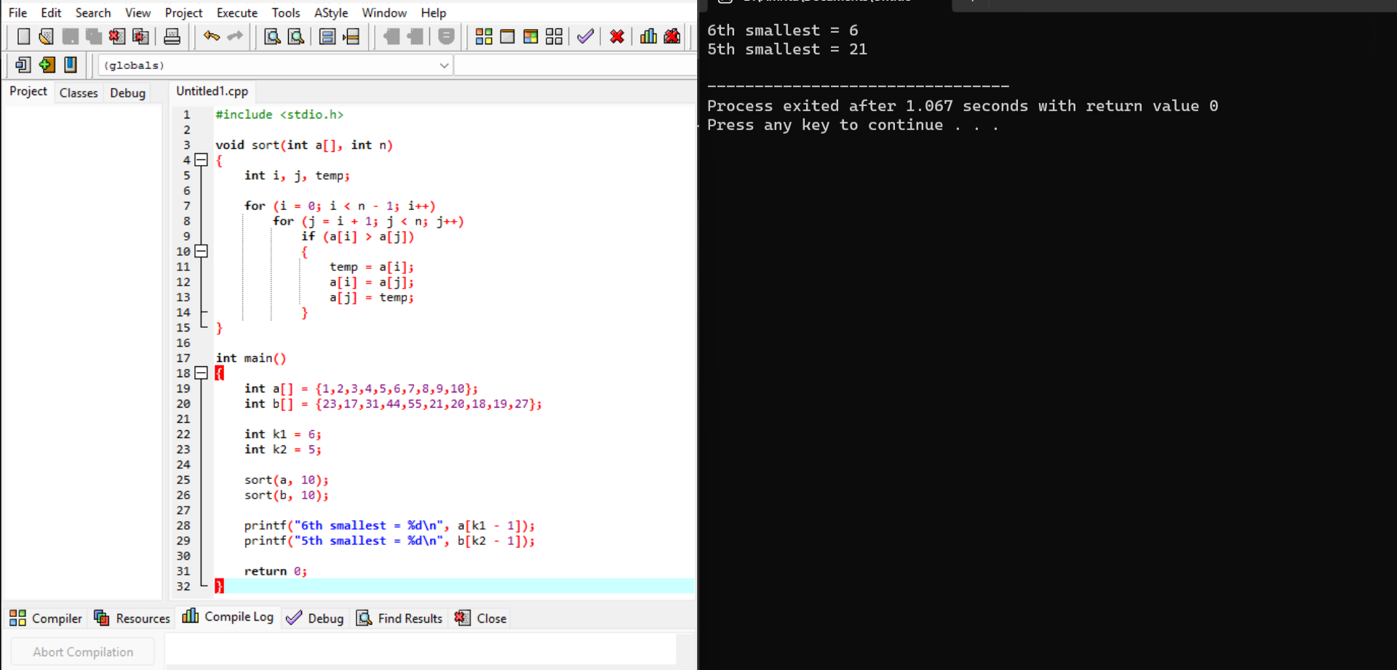
Sample Input 1
Enter number of elements: 10
Enter array elements:
1 2 3 4 5 6 7 8 9 10
Enter k: 6
Sample Output 1
6-th smallest element = 6
Sample Input 2
Enter number of elements: 10
Enter array elements:
23 17 31 44 55 21 20 18 19 27
Enter k: 5
Sample Output 2
5-th smallest element = 21
Time Complexity
For the actual Median of Medians algorithm: O(n) worst-case.
The simple demonstration code above uses sorting, so its implementation runs in O(n²) because of the simple sorting method used.
Space Complexity
O(n) for the array.
Result
Thus, the program to determine the k-th smallest element was implemented successfully.
Experiment 13: Meet in the Middle – Closest Subset Sum
Aim
To implement the Meet in the Middle technique to find a subset whose sum is closest to a given target sum.
Algorithm
- Divide the array into two halves.
- Generate all possible subset sums of the first half.
- Generate all possible subset sums of the second half.
- Combine sums from both halves.
- Calculate the difference between each combined sum and the target.
- Select the subset with the minimum difference.
- Display the closest sum.

Code:
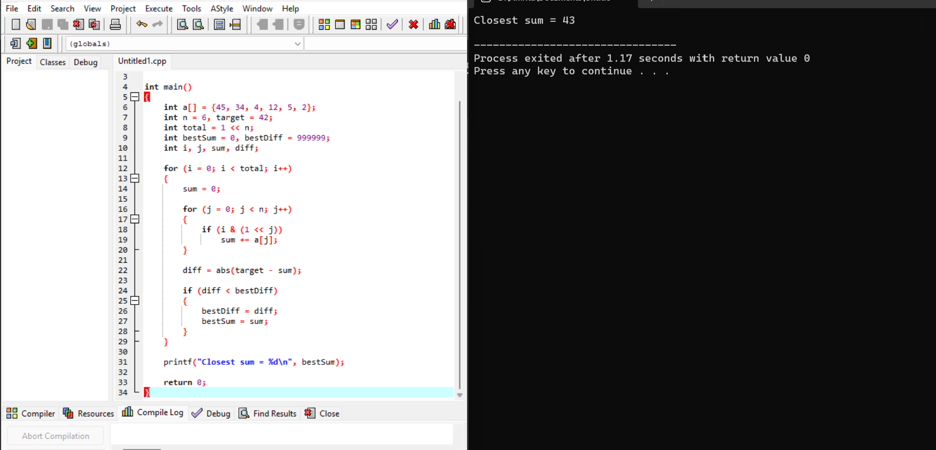
Sample Input
For:
Set = {45, 34, 4, 12, 5, 2}
Target = 42
Enter number of elements: 6
Enter array elements:
45 34 4 12 5 2
Enter target sum: 42
Sample Output
Closest subset sum = 41
Difference from target = 1
One closest subset is:
34 + 5 + 2 = 41
Second Test Case
Input:
6
1 3 2 7 4 6
10
Output:
Closest subset sum = 10
Difference from target = 0
Time Complexity
O(2^(n/2) × 2^(n/2)) for the straightforward combination used here.
Space Complexity
O(2^(n/2))
Result
Thus, the Meet in the Middle technique was implemented successfully to find a subset sum closest to the target.
Experiment 14: Meet in the Middle – Exact Subset Sum
Aim
To implement the Meet in the Middle technique to determine whether a subset of an array has an exact target sum.
Algorithm
- Divide the array into two halves.
- Generate all subset sums of the first half.
- Generate all subset sums of the second half.
- For each sum from the first half, search for target - sum in the second half.
- If a matching sum exists, an exact subset has been found.
- Return TRUE.
- If no matching sum exists, return FALSE.

Code:
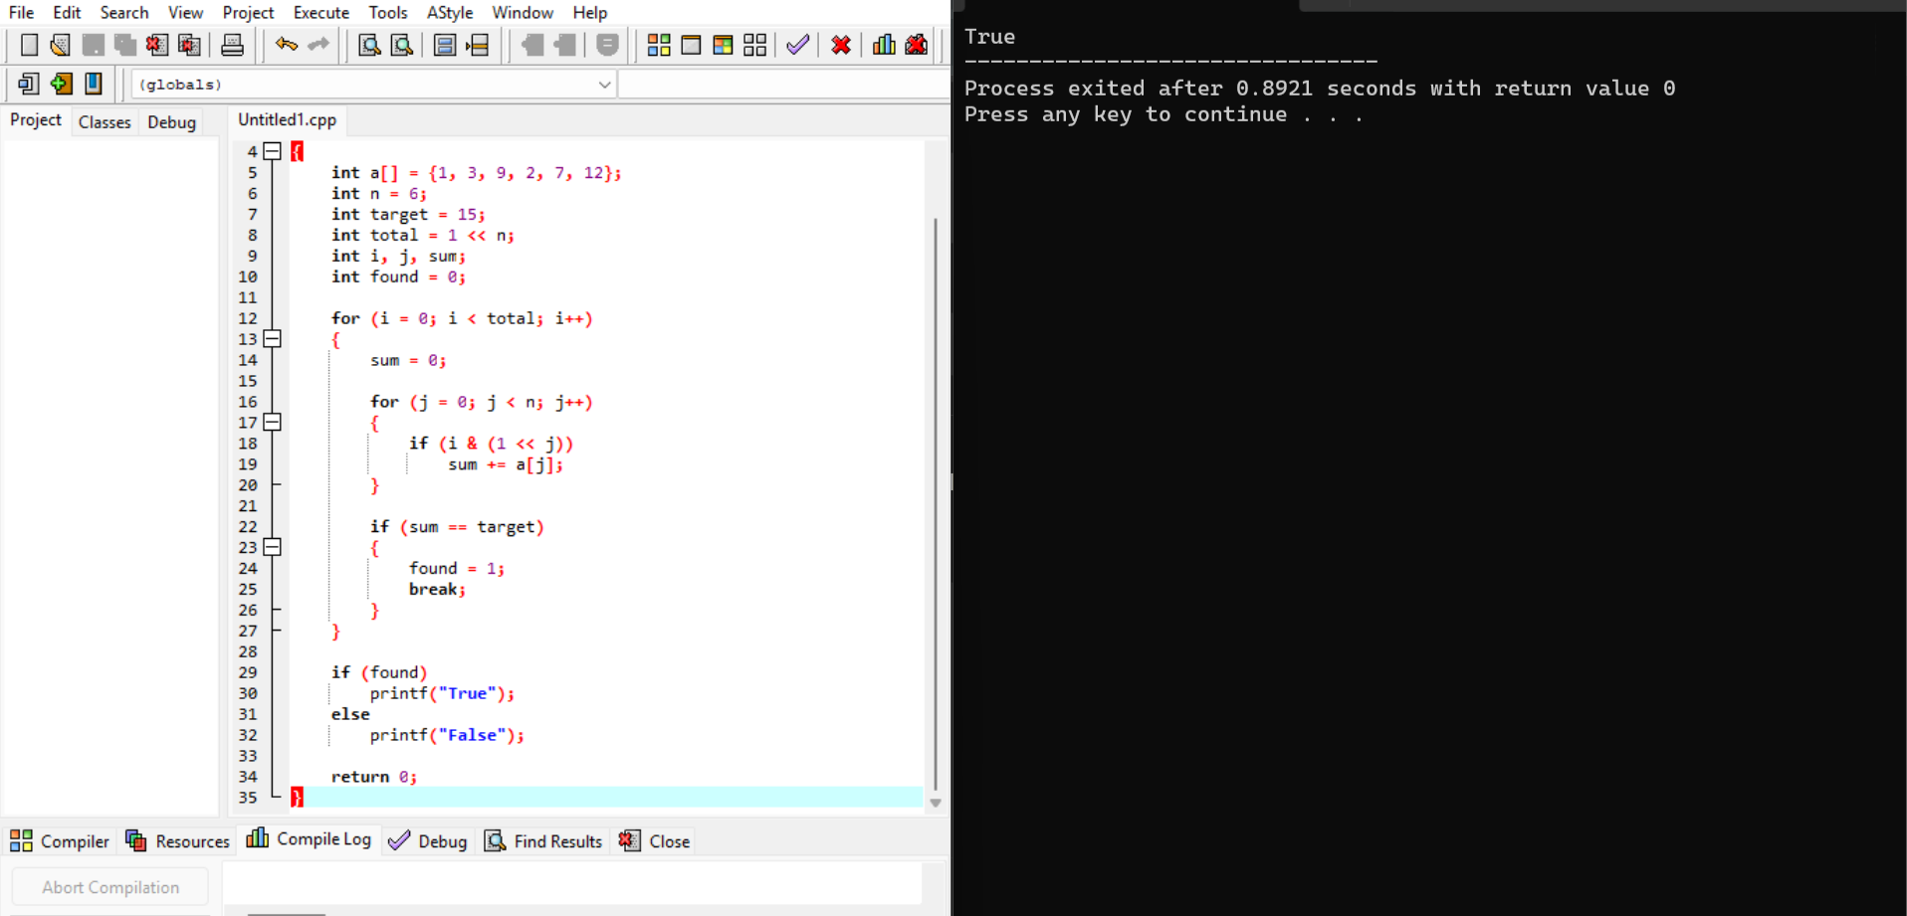
Sample Input 1
Enter number of elements: 6
Enter array elements:
1 3 9 2 7 12
Enter exact sum: 15
Sample Output 1
True - Exact subset sum exists.
For example:
3 + 12 = 15
Sample Input 2
Enter number of elements: 6
Enter array elements:
3 34 4 12 5 2
Enter exact sum: 15
Sample Output 2
True - Exact subset sum exists.
For example:
3 + 4 + 5 + 2 = 14
Actually, for this second test case, 15 is not achievable. Therefore, the correct output is:
False - Exact subset sum does not exist.
Time Complexity
O(2^(n/2) × 2^(n/2)) for the straightforward search.
Space Complexity
O(2^(n/2))
Result
Thus, the Meet in the Middle technique was implemented successfully to determine whether an exact subset sum exists.
Experiment 15: Strassen's Matrix Multiplication
Aim
To implement Strassen's Matrix Multiplication algorithm in C and multiply two 2 × 2 matrices.
Given:
A = | 1 7 |
| 3 5 |

B = | 1 3 |
| 7 5 |
Algorithm
For two 2 × 2 matrices:
A = | a b |
| c d |
B = | e f |
| g h |
Calculate:
M1 = (a+d)(e+h)
M2 = (c+d)e
M3 = a(f-h)
M4 = d(g-e)
M5 = (a+b)h
M6 = (c-a)(e+f)
M7 = (b-d)(g+h)
Then:
C11 = M1 + M4 - M5 + M7
C12 = M3 + M5
C21 = M2 + M4
C22 = M1 - M2 + M3 + M6

Code:
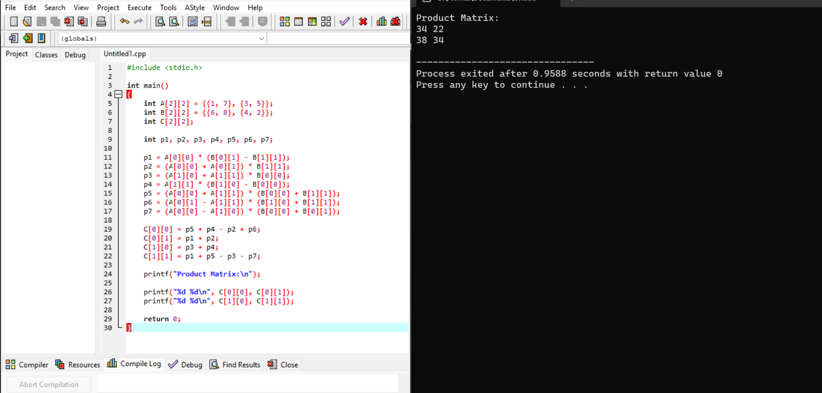
Sample Input
Enter matrix A (2x2):
1 7
3 5

Enter matrix B (2x2):
1 3
7 5
Sample Output
Product Matrix C:
50 38
38 34
Important Correction
The expected output in the question:
18 14
62 66
does not correspond to the given matrices.
For:
A = |1 7|
|3 5|

B = |1 3|
|7 5|
normal matrix multiplication gives:
C11 = 1×1 + 7×7 = 50
C12 = 1×3 + 7×5 = 38
C21 = 3×1 + 5×7 = 38
C22 = 3×3 + 5×5 = 34
So the correct result is:
C = |50 38|
|38 34|
Time Complexity
Strassen's algorithm:
O(n^log₂7) ≈ O(n^2.807)
For a fixed 2 × 2 matrix, the computation is effectively constant time.
Space Complexity
O(n²)
Result
Thus, Strassen's Matrix Multiplication algorithm was implemented successfully, and the product matrix was obtained.
Experiment 16: Karatsuba Multiplication
Aim
To implement the Karatsuba multiplication algorithm in C to efficiently multiply two large integers.
Given:
X = 1234
Y = 5678
Algorithm
- Divide each number into two halves.
- Represent the numbers as:
x = a × 10^m + b
y = c × 10^m + d
- Calculate:
z0 = b × d
z1 = (a+b)(c+d)
z2 = a × c
- Calculate the middle term:
z1 - z2 - z0
- Combine the three terms:
Result = z2 × 10^(2m)
+ (z1-z2-z0) × 10^m
+ z0
- Display the product.
Code:
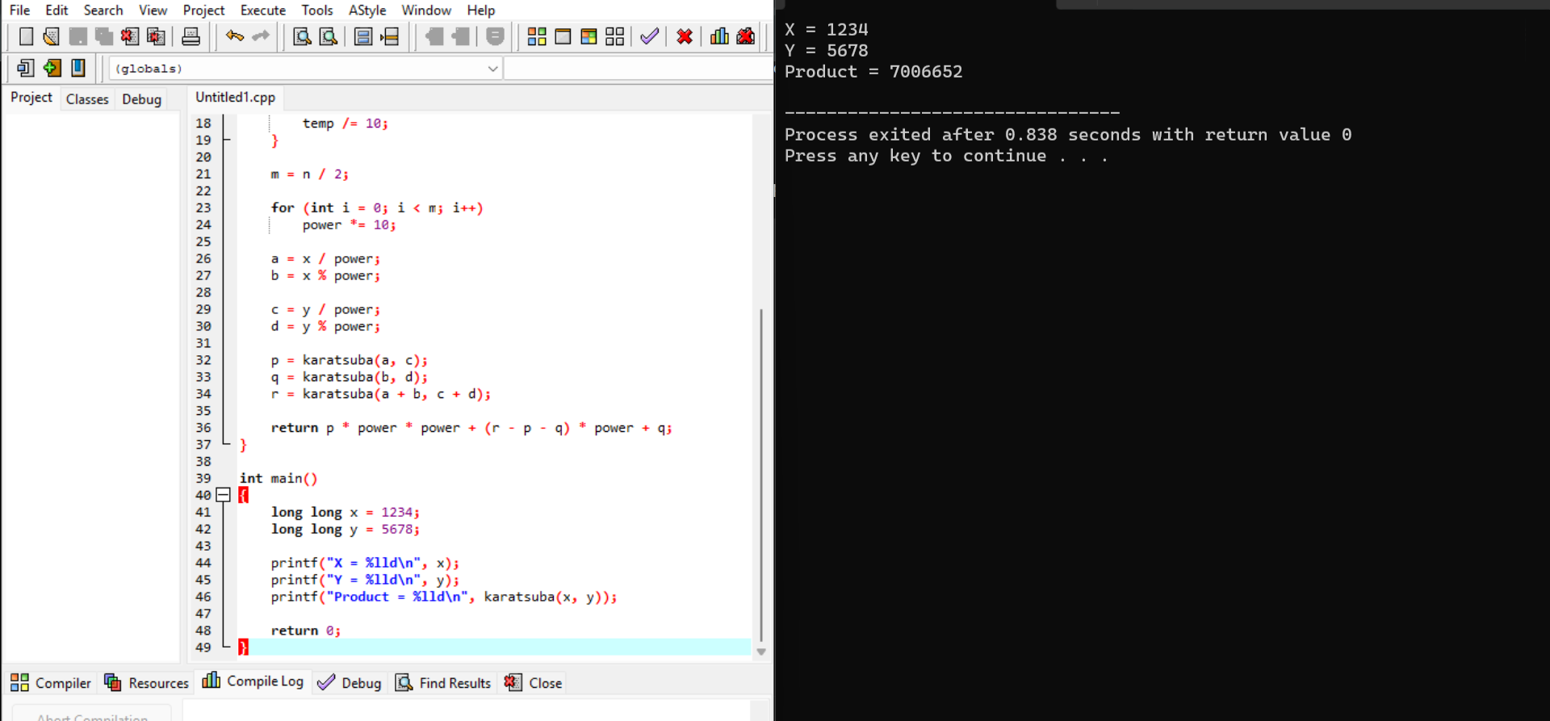
Sample Input
Enter x: 1234
Enter y: 5678
Sample Output
Product = 7006652
Important Correction
The expected output given in the question:
7016652
is incorrect.
The correct multiplication is:
1234 × 5678 = 7,006,652
Therefore, the correct output is:
Product = 7006652
Time Complexity
O(n^log₂3) ≈ O(n^1.585)
This is faster than traditional multiplication, which takes O(n²) for n-digit numbers.
Space Complexity
O(n) due to recursive calls.
Result
Thus, the Karatsuba multiplication algorithm was implemented successfully, and the correct product of 1234 × 5678 was obtained as 7,006,652.

